NAME: CHRISTINA JOSE MANAKKAL

ROLL NO: 48 CLASS: TE IT B3 PID: 191064

St. Francis Institute of Technology, Mumbai-400 103

**Department Of Information Technology**

A.Y. 2021-2022

Class: TE-IT B, Semester: V

Subject: **DevOps Lab**

**Experiment – 6:** **To** **understand master-slave architecture and scale your Jenkins standalone implementation by implementing slave nodes.**

1. **Aim:** To understand master-slave architecture and scale your Jenkins standalone implementation by implementing slave nodes
2. **Objectives:** Aim of this experiment is that, the students will be able to do

* Jenkins management
* Adding a slave node to Jenkins

1. **Outcomes:** After study of this experiment, the students will be able

* To understand the importance of Jenkins to Build and deploy Software

Applications on server environment.

1. **Prerequisite:** Knowledge of Computer Networks concept of Master-slave architecture
2. **Requirements:** Jenkins,JDK, python,Personal Computer, Windows operating system, browser, Internet Connection, Microsoft Word.



1. **Pre-Experiment Exercise:**

**Brief Theory:** Refer shared material

1. **Laboratory Exercise**
   * + 1. **Procedure:**

**a. Answer the following:**

* Explain the architecture of Jenkins with diagram.

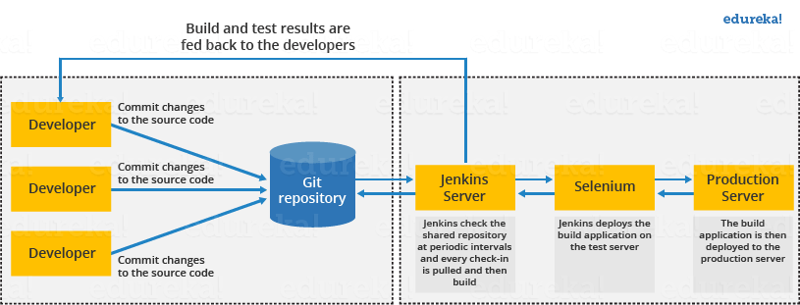



* First of all, a developer commits the code to the source code repository. Meanwhile, the Jenkins checks the repository at regular intervals for changes.
* Soon after a commit occurs, the Jenkins server finds the changes that have occurred in the source code repository. Jenkins will draw those changes and will start preparing a new build.
* If the build fails, then the concerned team will be notified.
* If built is successful, then Jenkins server deploys the built in the test server.
* After testing, Jenkins server generates a feedback and then notifies the developers about the build and test results.
* It will continue to verify the source code repository for changes made in the source code and the whole process keeps on repeating.
* Explain the distributed architecture of Jenkins with diagram

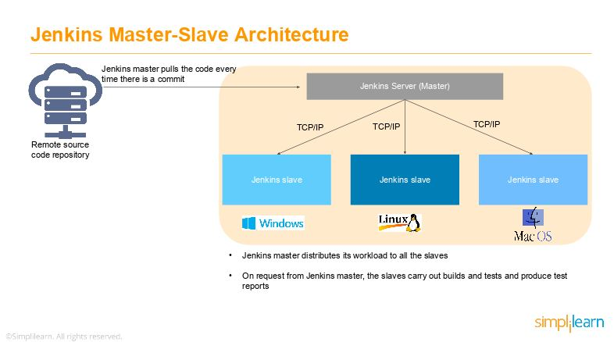

* As you can see in the diagram provided above, on the left is the Remote source code repository. The Jenkins server accesses the master environment on the left side and the master environment can push down to multiple other Jenkins Slave environments to distribute the workload.
* That lets you run multiple builds, tests, and product environment across the entire architecture. Jenkins Slaves can be running different build versions of the code for different operating systems and the server Master controls how each of the builds operates.
* Supported on a master-slave architecture, Jenkins comprises many slaves working for a master. This architecture - the Jenkins Distributed Build - can run identical test cases in different environments. Results are collected and combined on the master node for monitoring.

**b**. **Execute following (Refer the shared material) and attach screenshots:**

* Create a slave node and connect it to master
* Use an existing project or a new project to run in the slave node

1. **Post-Experiments Exercise**
2. **Extended Theory:**

Nil

1. **Questions:**

* What are the ways to configure Jenkins node agent to communicate with Jenkins master?
* Which architecture is recommended for a scalable Jenkins environment?

1. **Conclusion:**

* Write what was performed in the experiment.
* Write the significance of the topic studied in the experiment.

1. **References:**

<https://jenkins.io/doc/>

<https://www.slideshare.net/abediaz/introduction-to-jenkins>

https://www.studytonight.com/jenkins/jenkins-master-slave-configuration

<https://www.edureka.co/blog/jenkins-master-and-slave-architecture-a-complete-guide/>

**b**. **Execute following (Refer the shared material) and attach screenshots:**

* Create a slave node and connect it to master

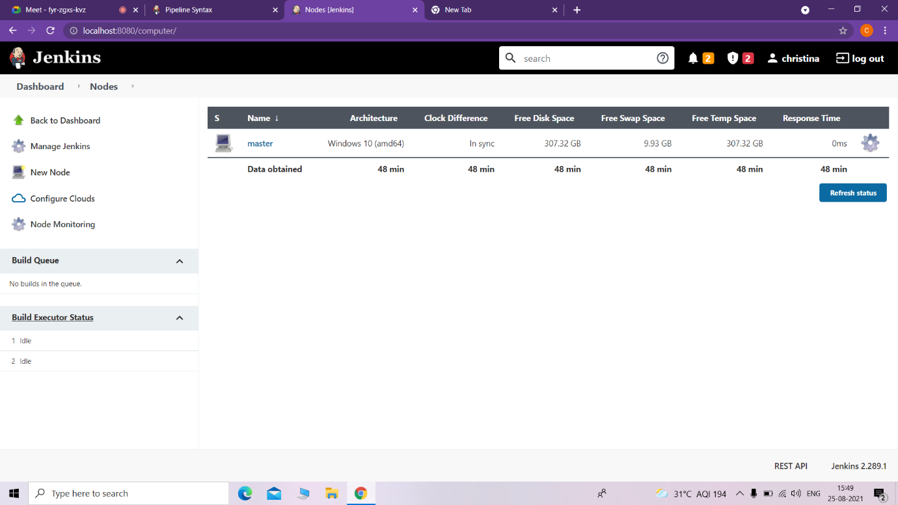

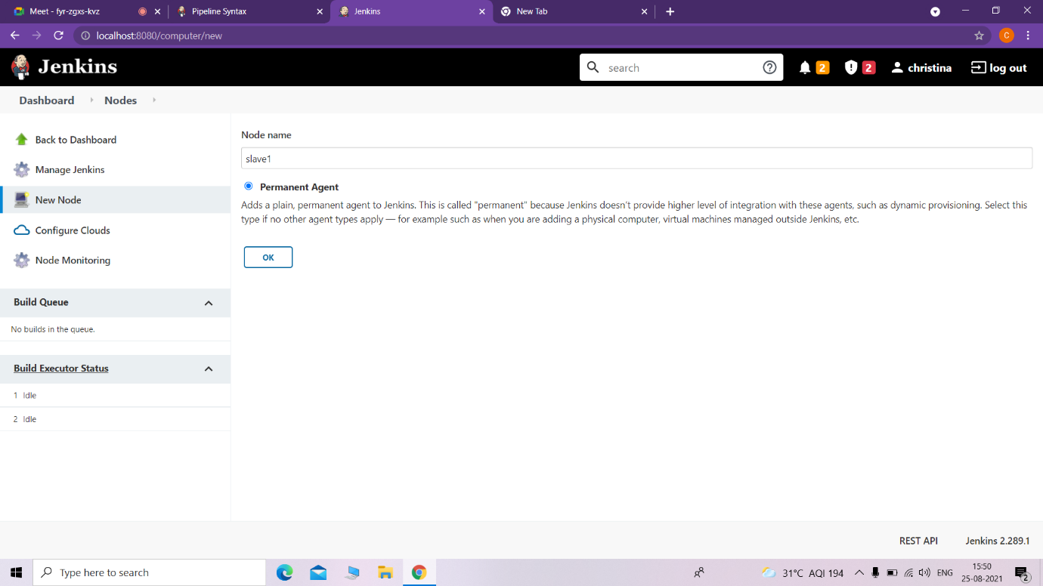

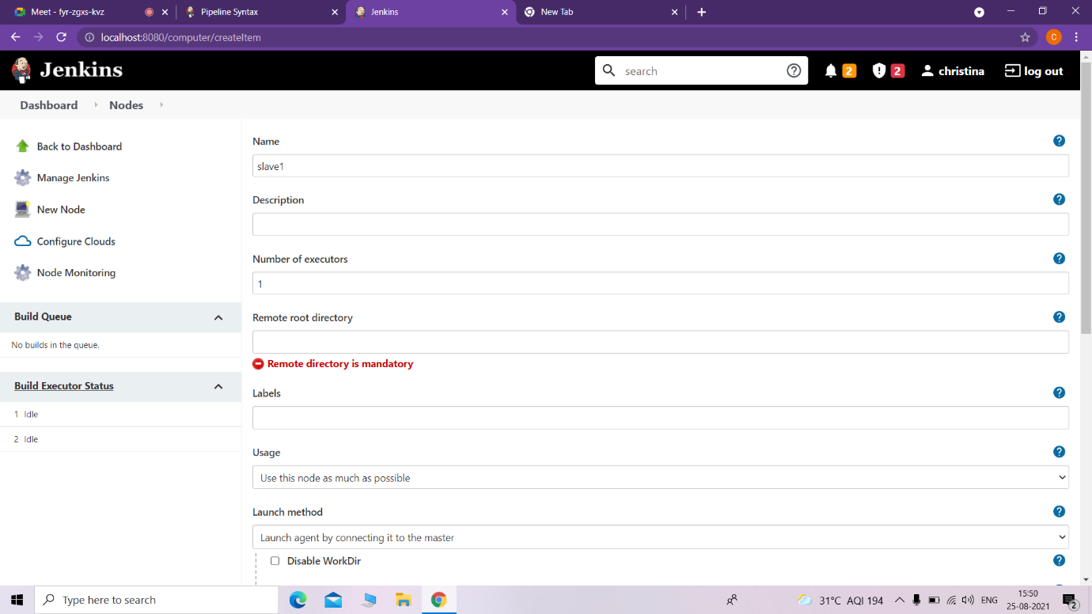

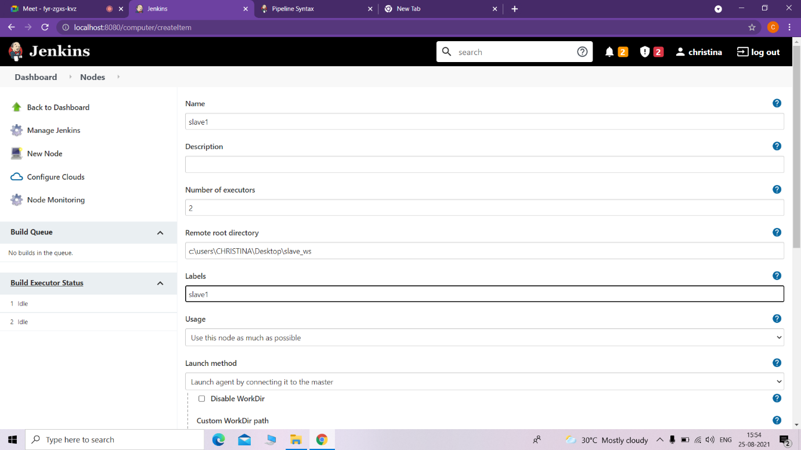

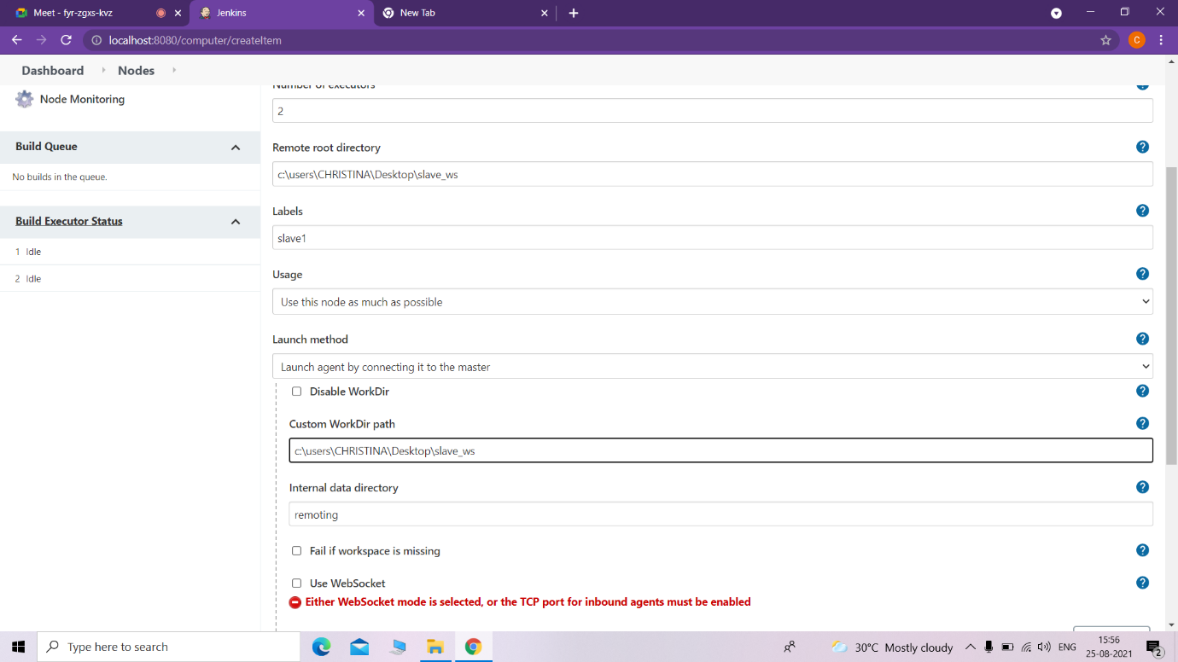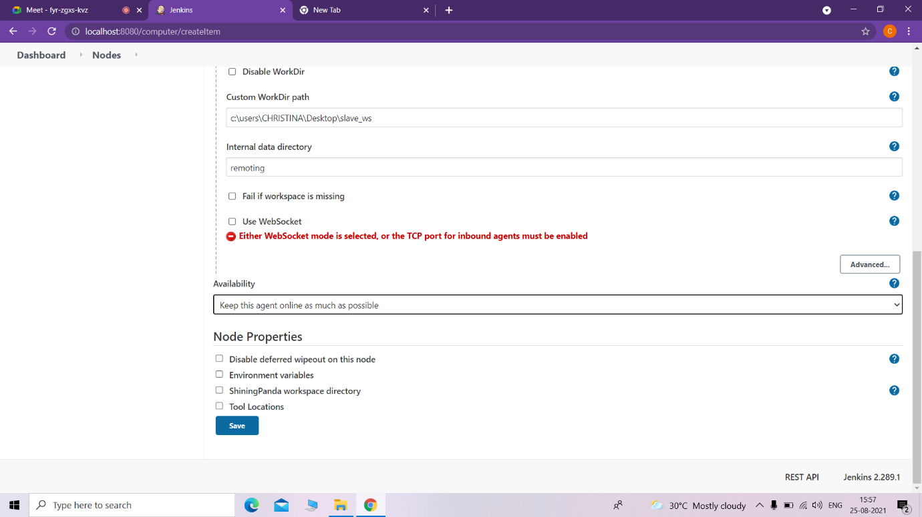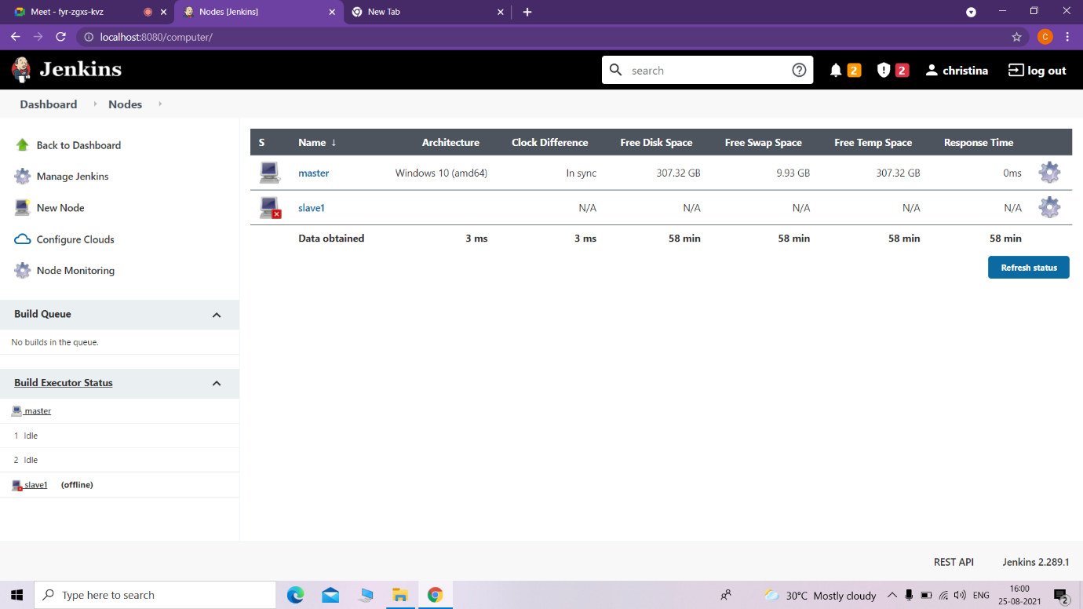

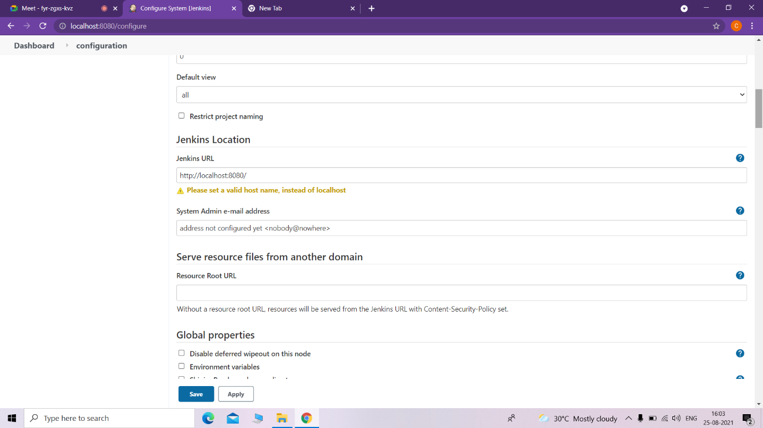

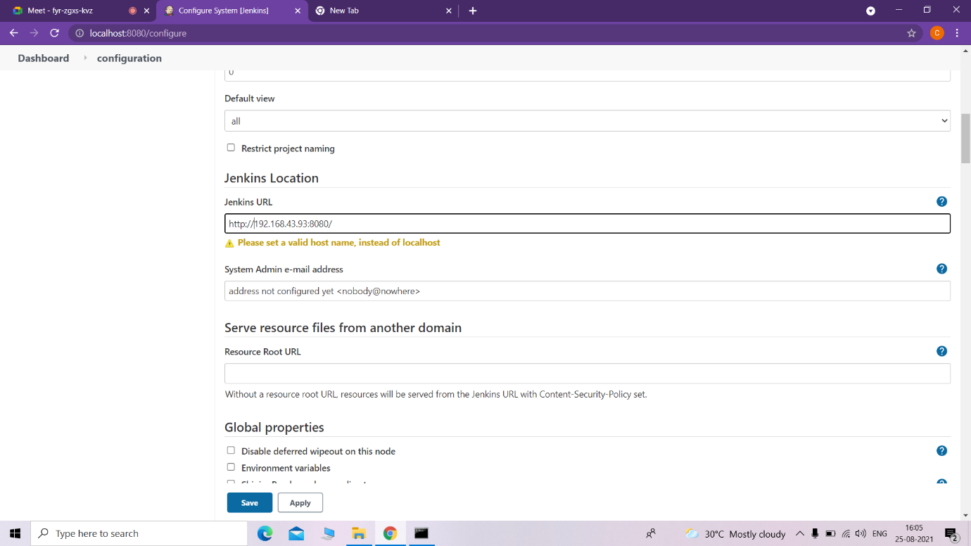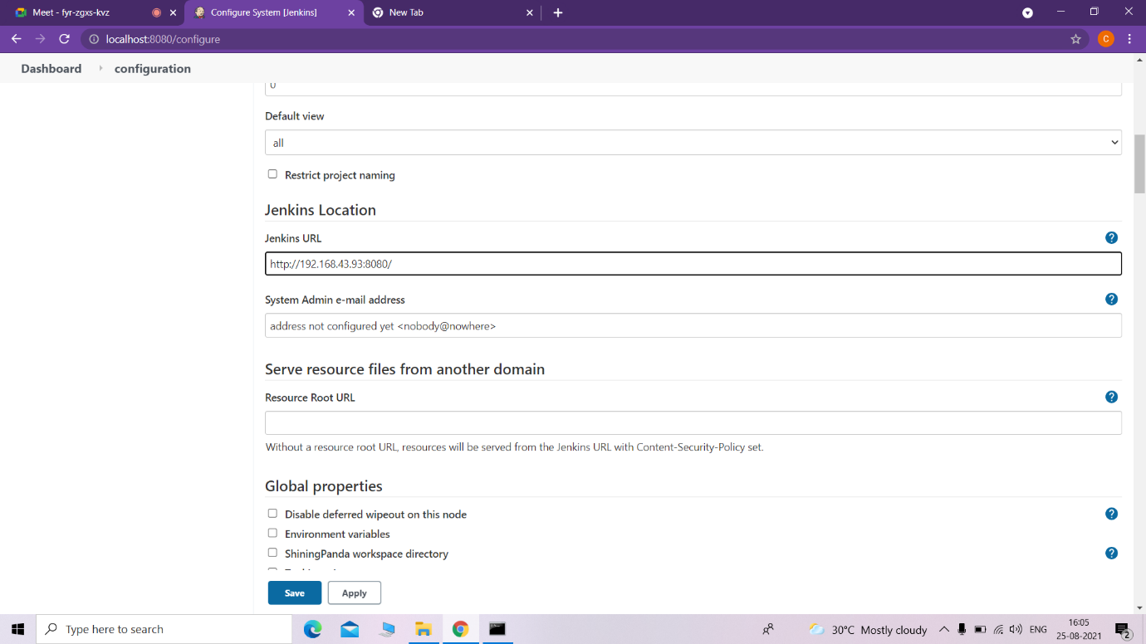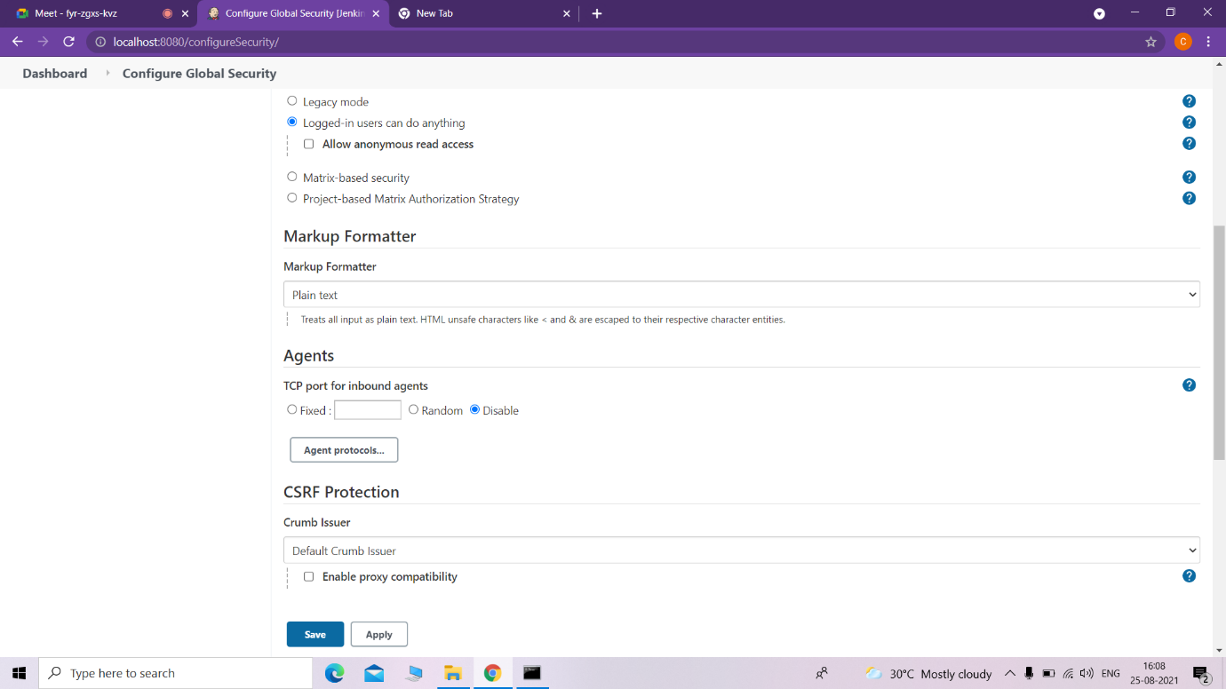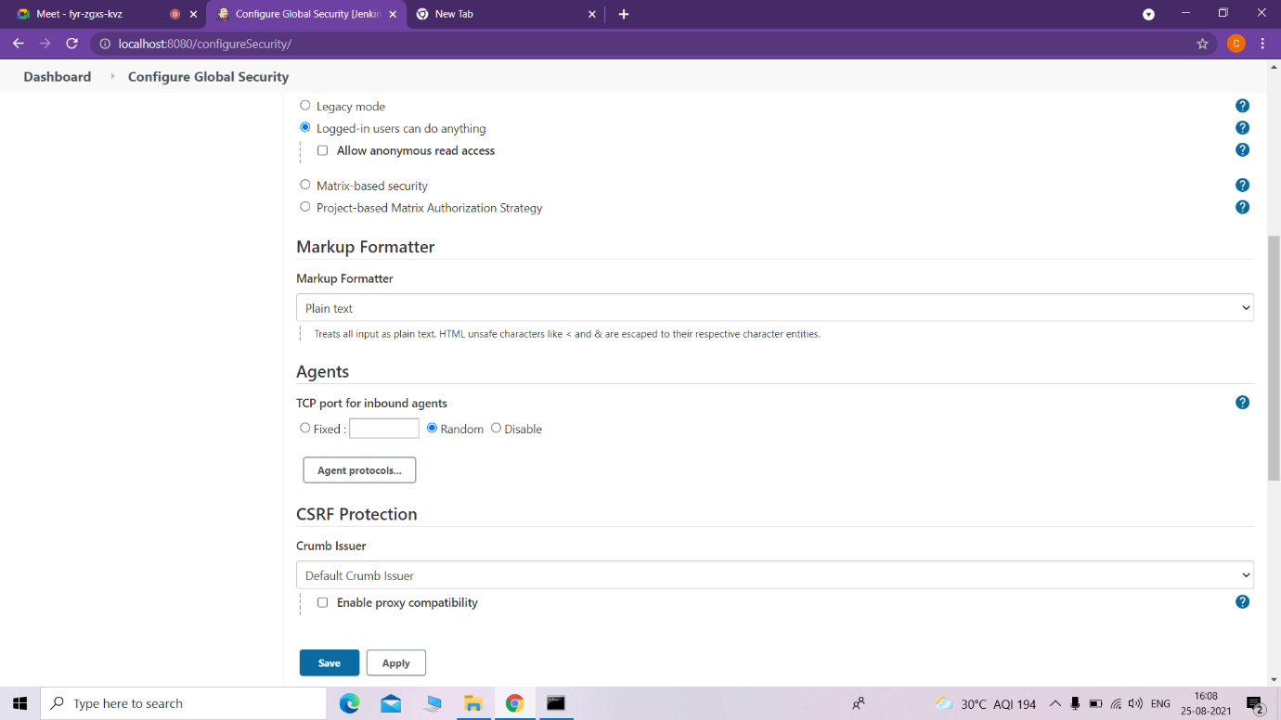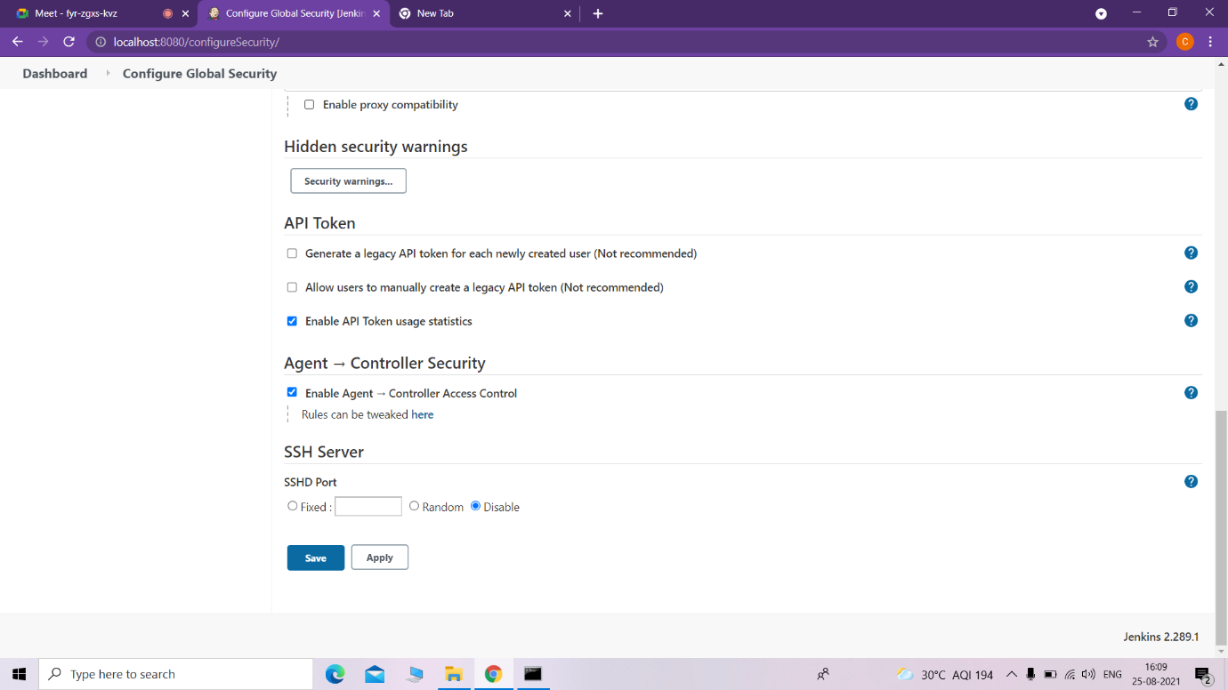

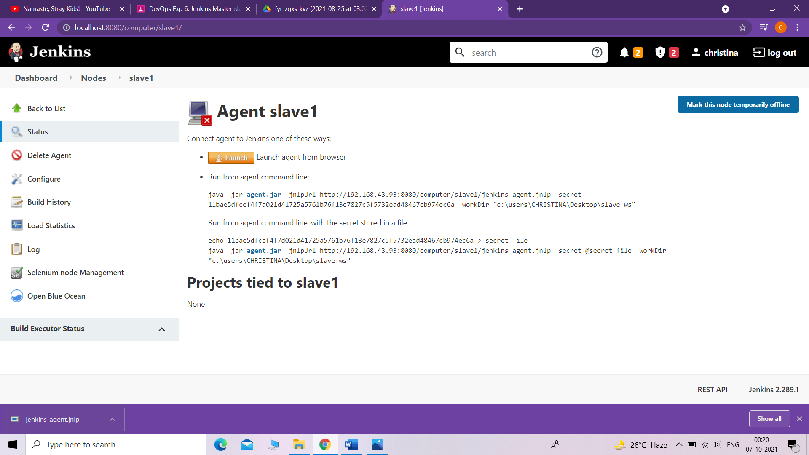

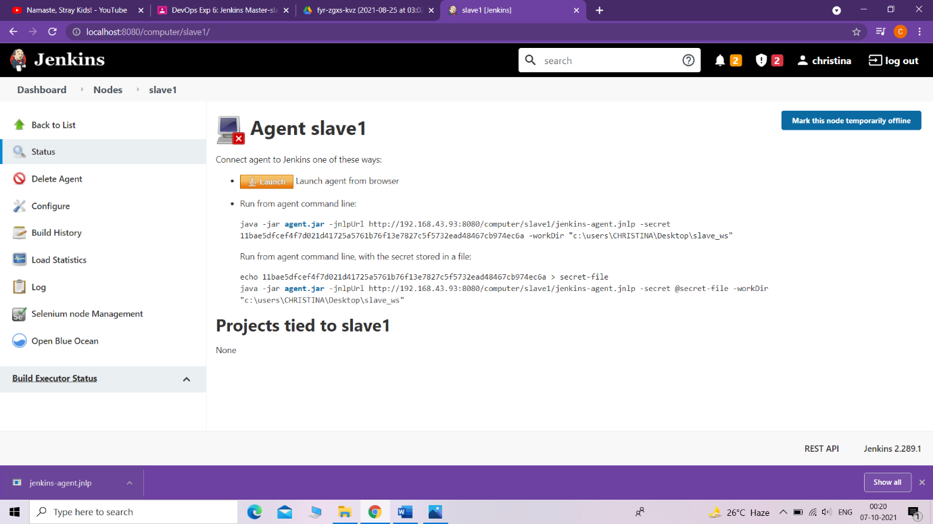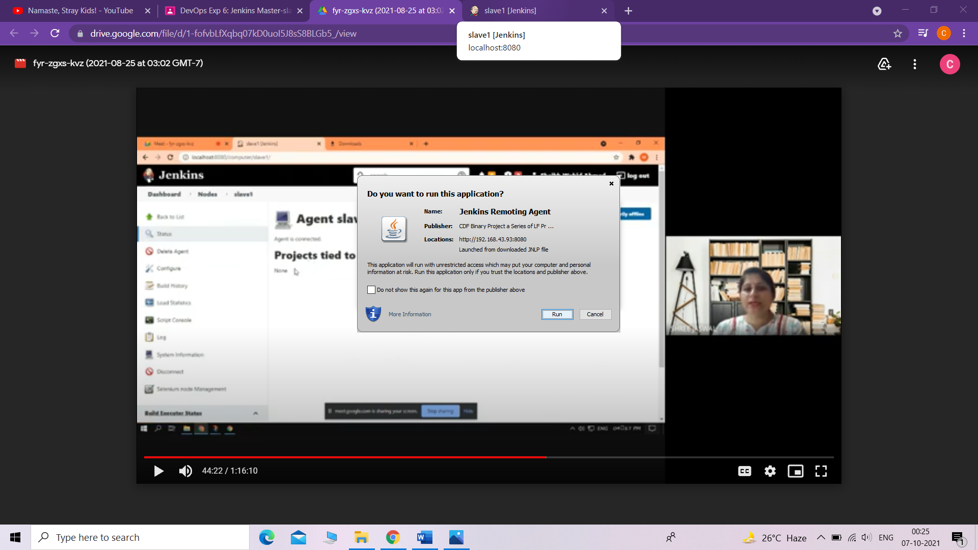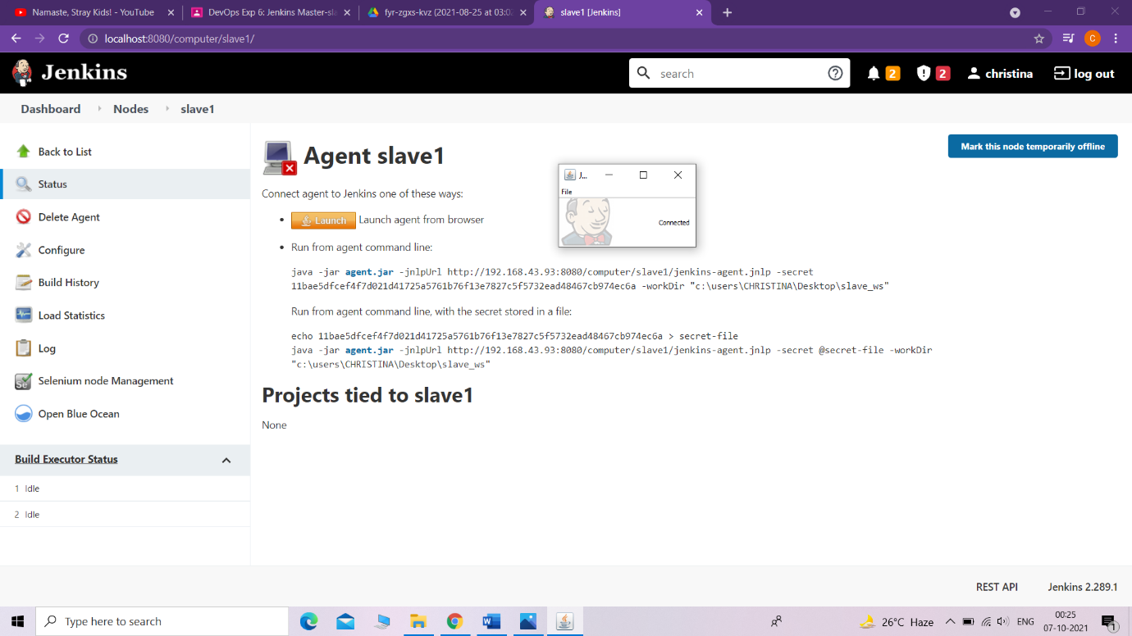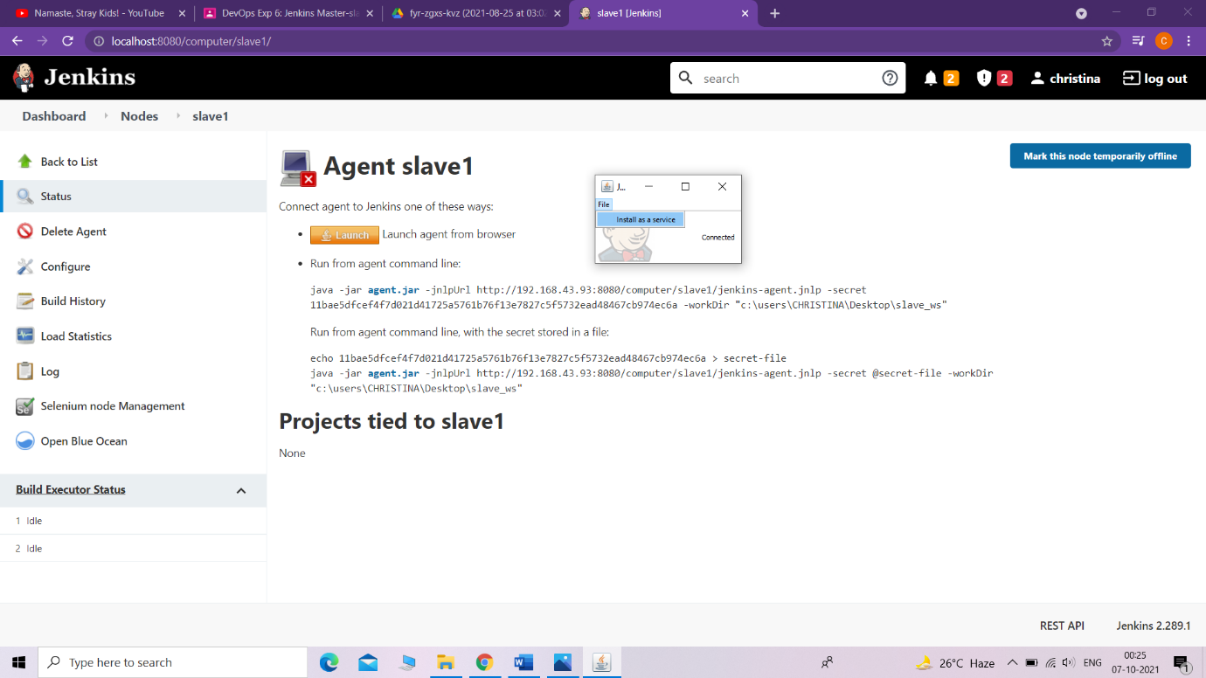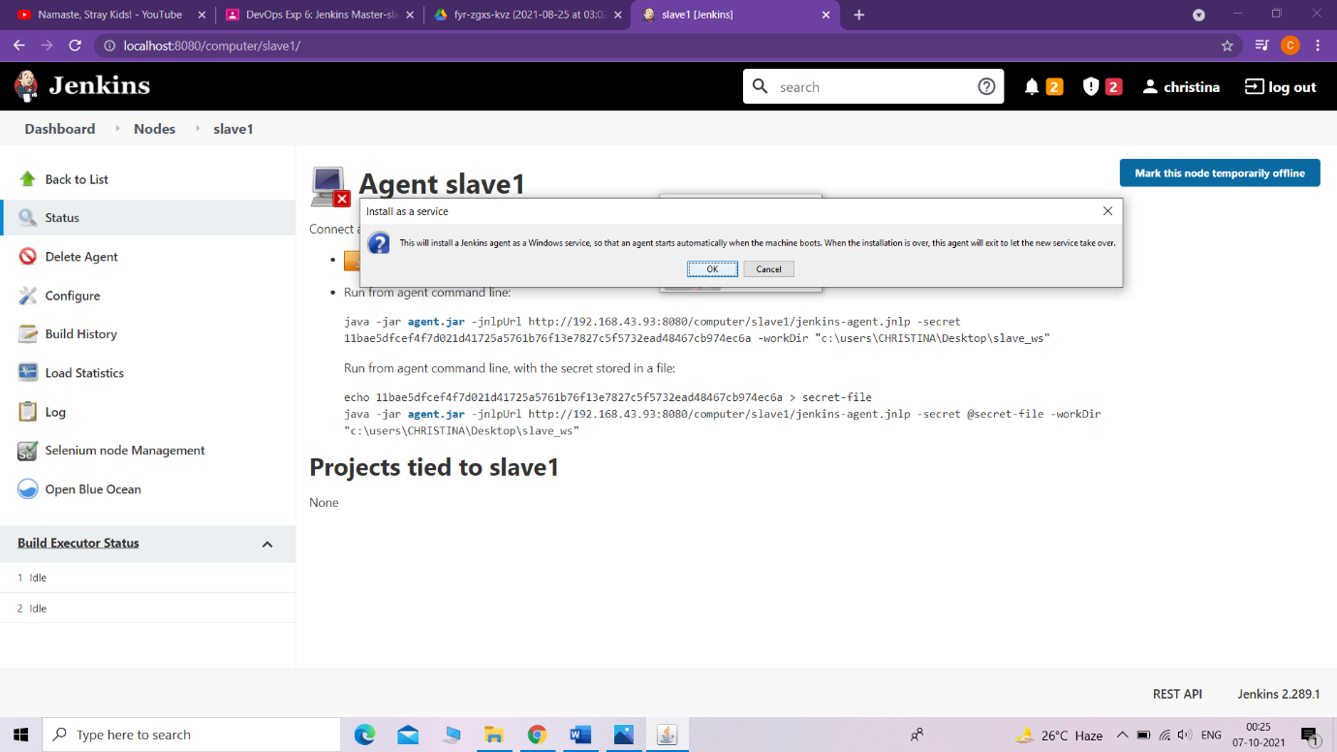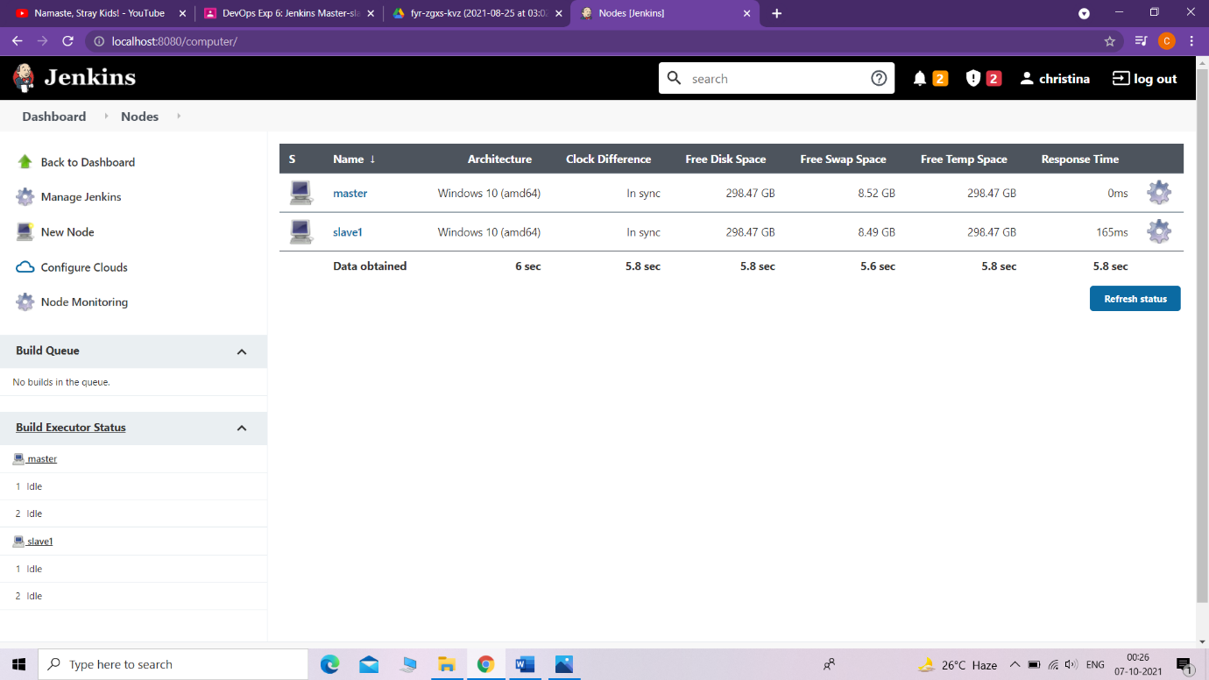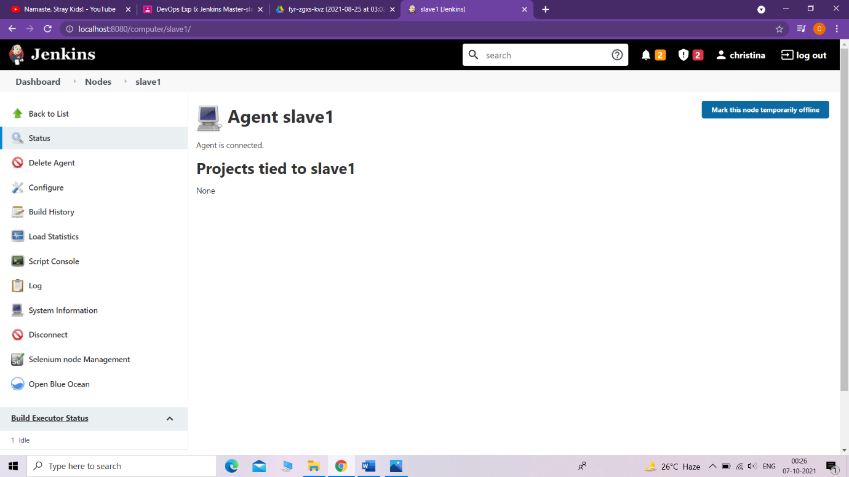

* Use an existing project or a new project to run in the slave node

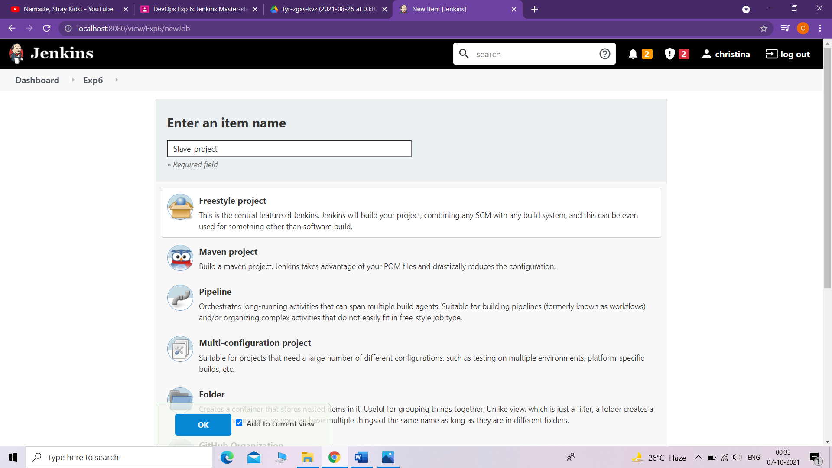

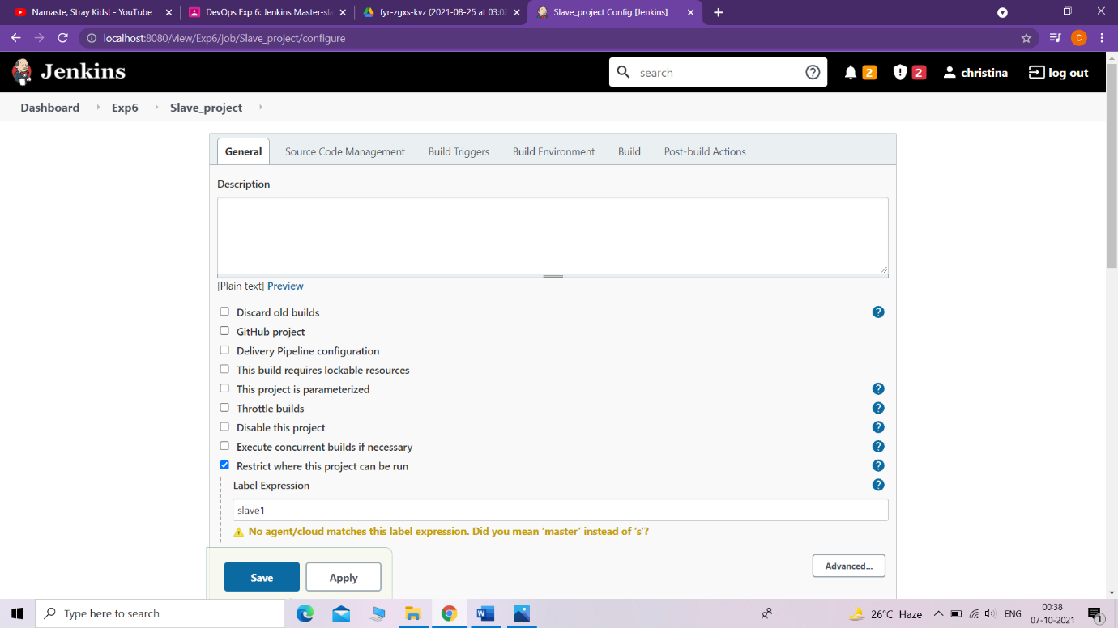

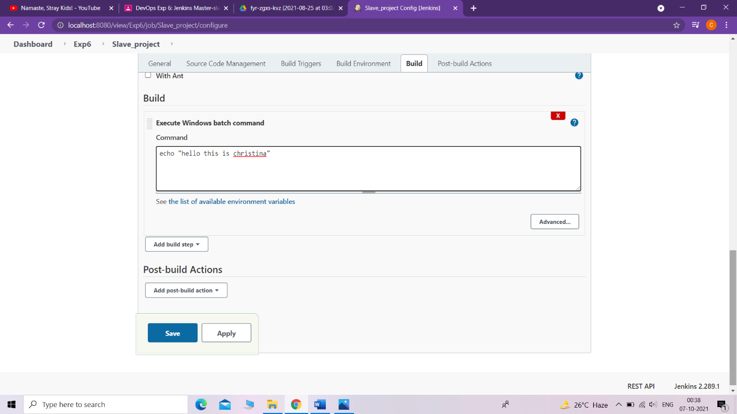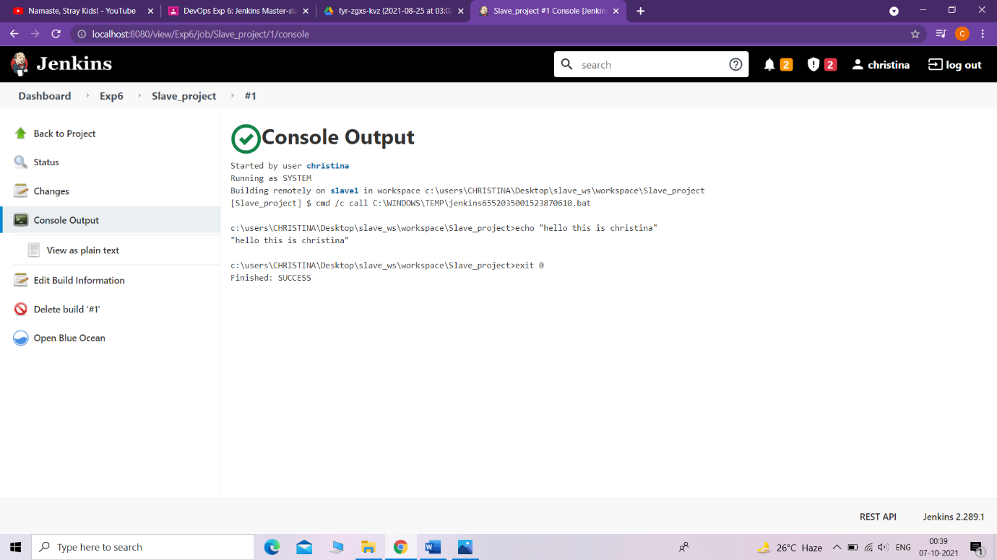

Making the node offline temporarily:

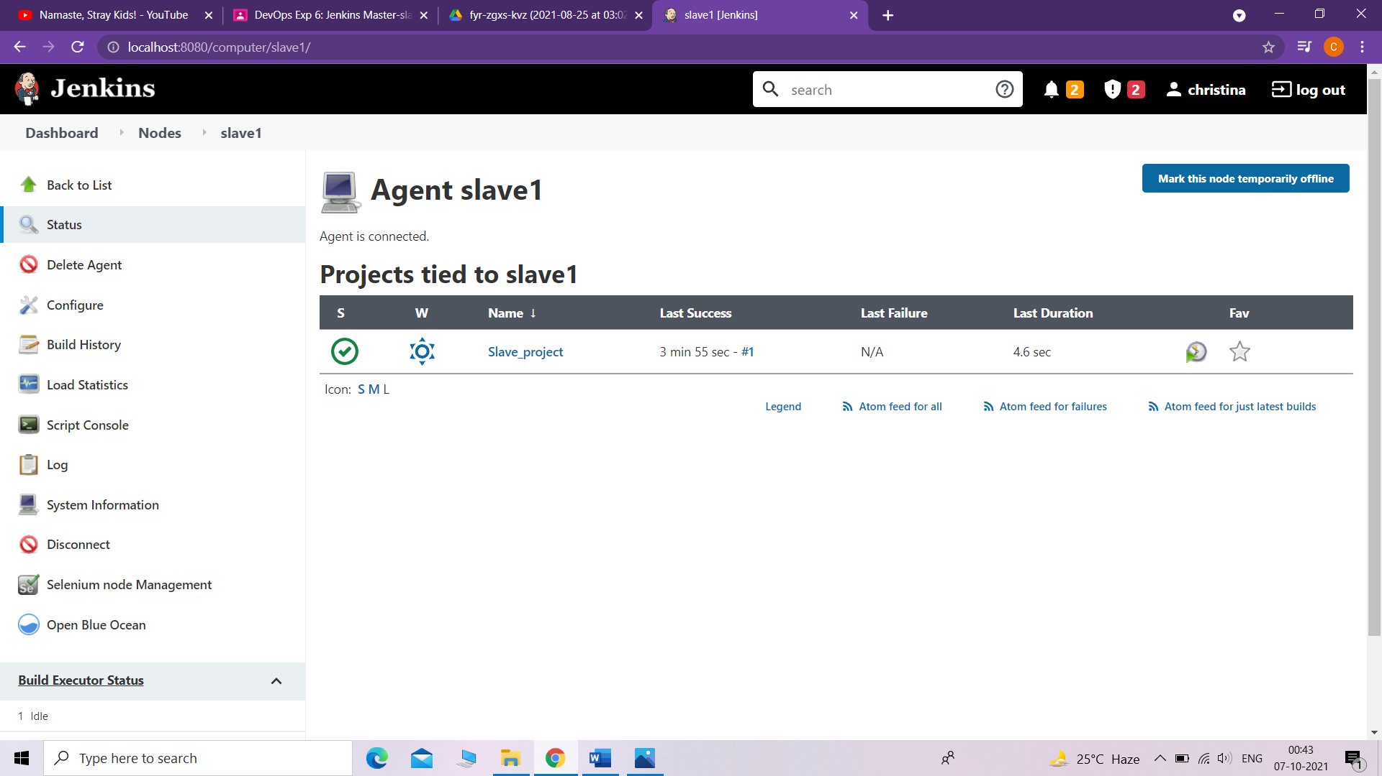

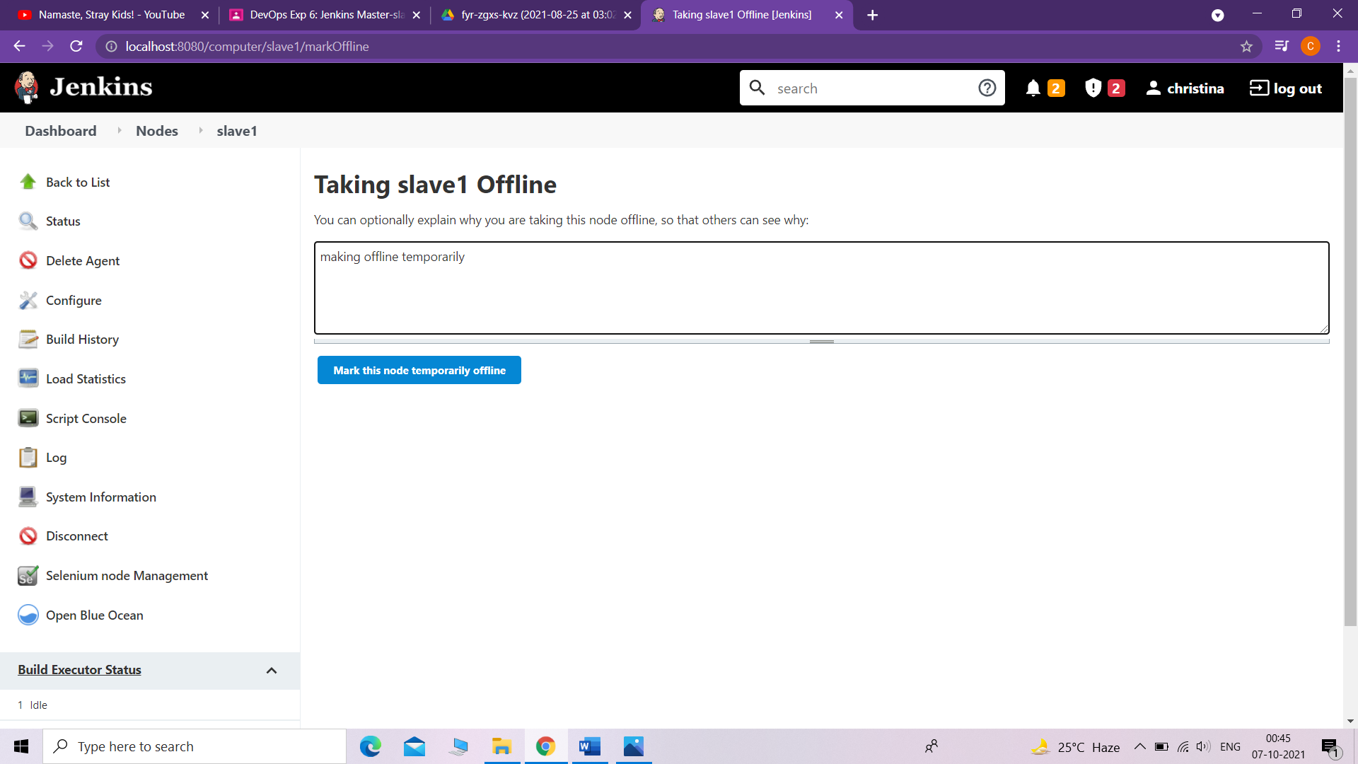

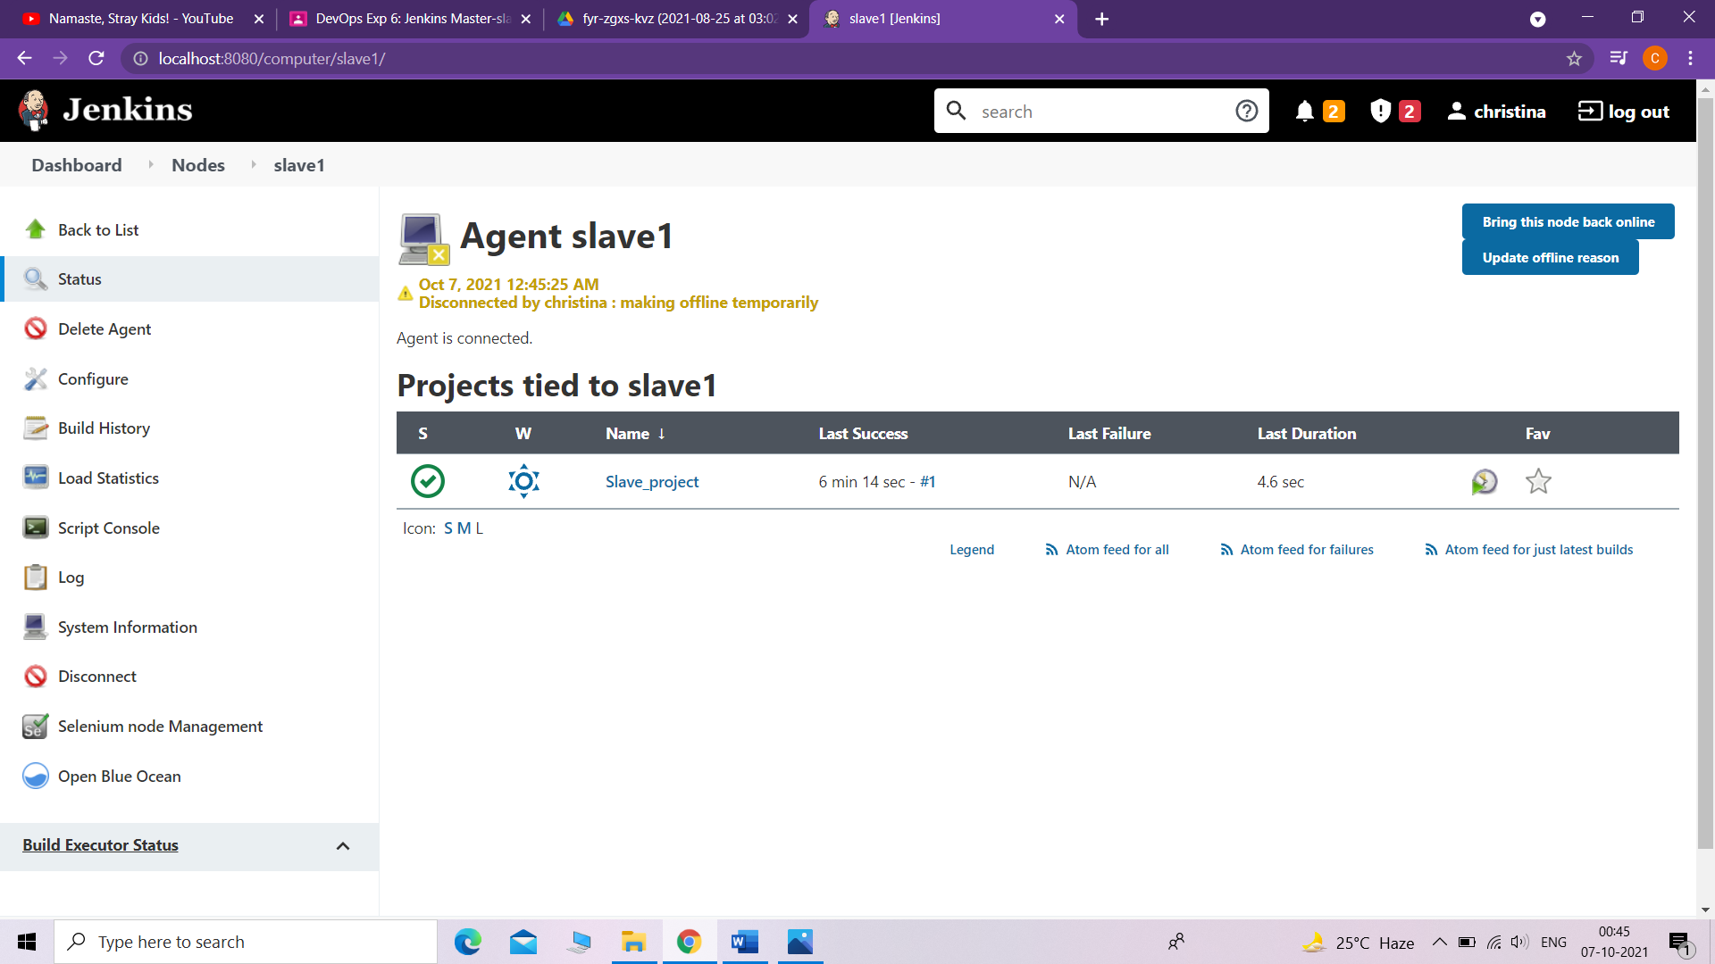

Disconnecting the node:

